**Data Collection and Preprocessing Phase**

**Data Collection :**

We have used the following data for the model to train on :

<https://docs.google.com/spreadsheets/d/1RA2OO0LZTeQykI_mvnensAjp6LM4YzWI1Tz0SUG5-Ao/edit?gid=121883362#gid=121883362>

**Data Quality Report :**

Analyzing the data:

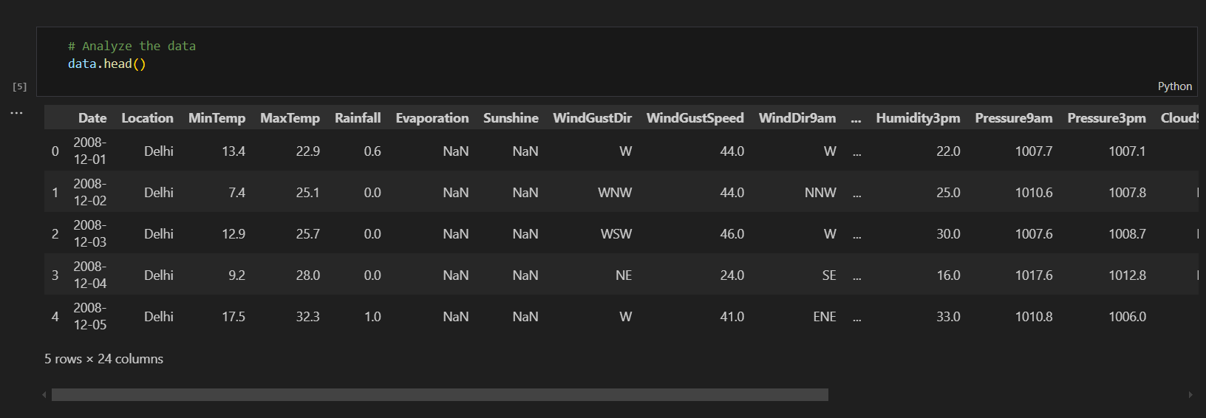

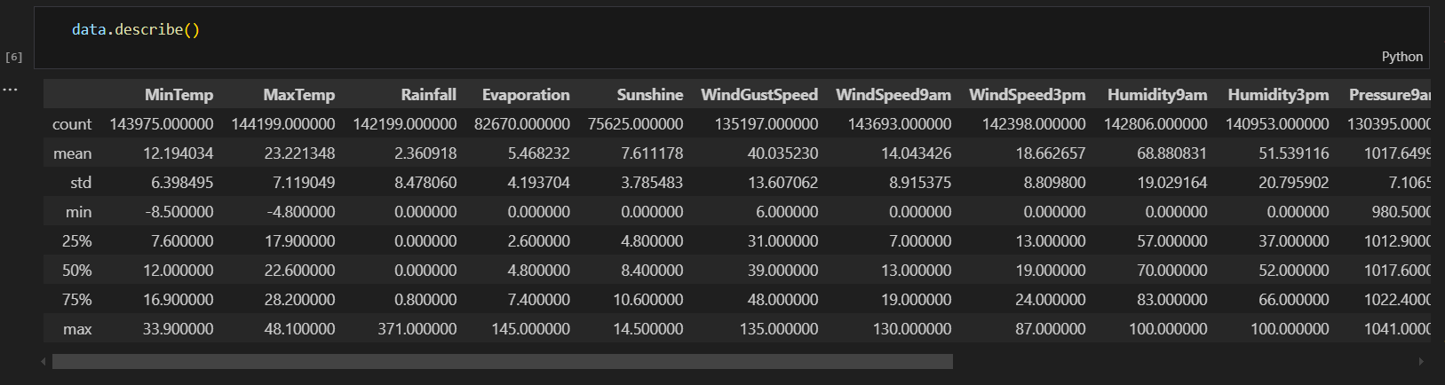

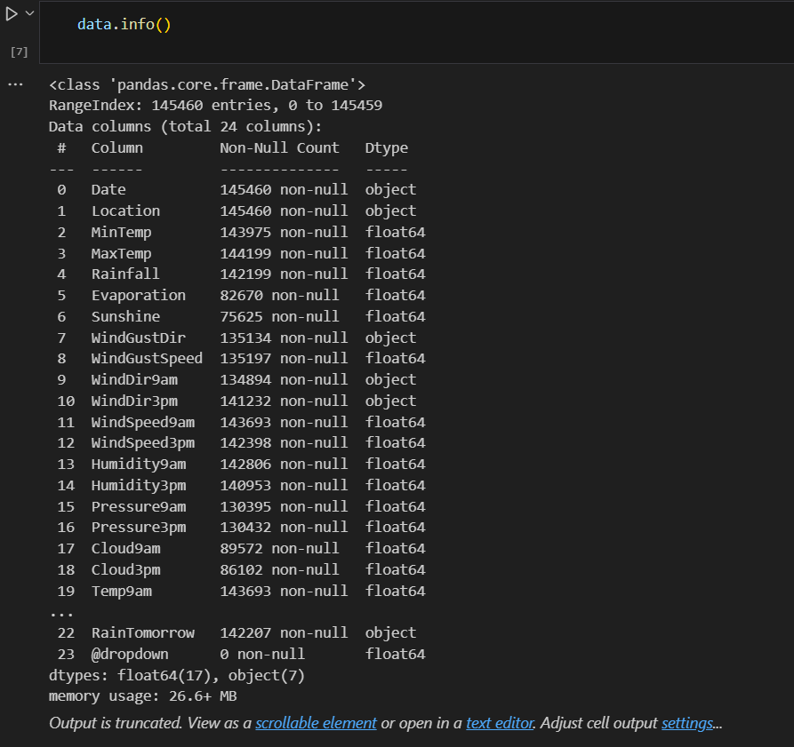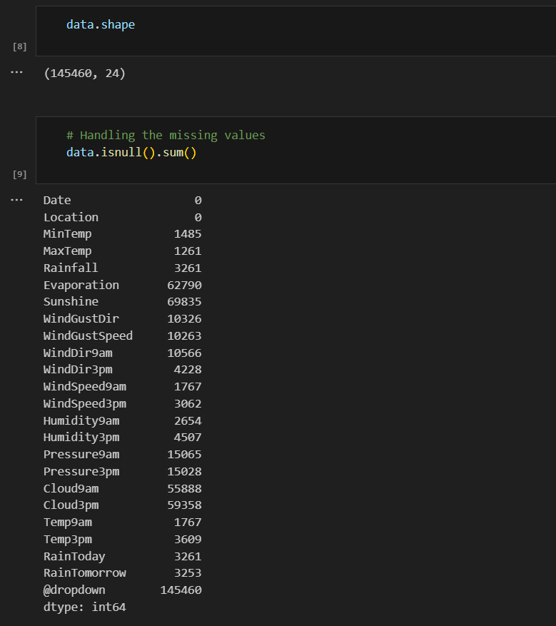

**Preprocessing Report : ( Visualisation Report )**

1. **The HeatMap of the data**

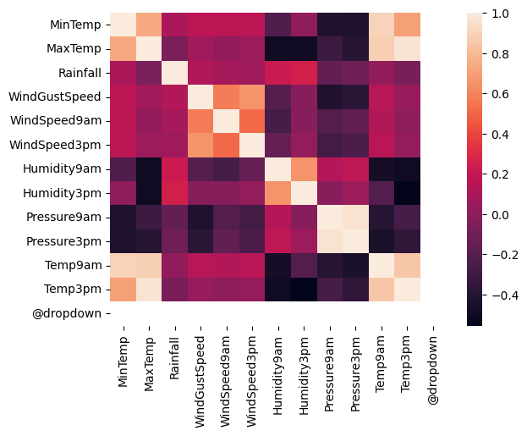

1. **The Boxplot**

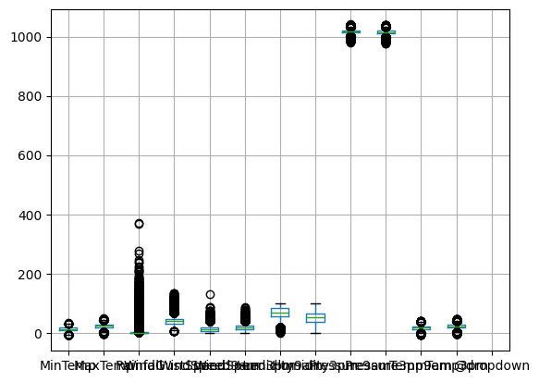

1. **The Jointplot - 1**

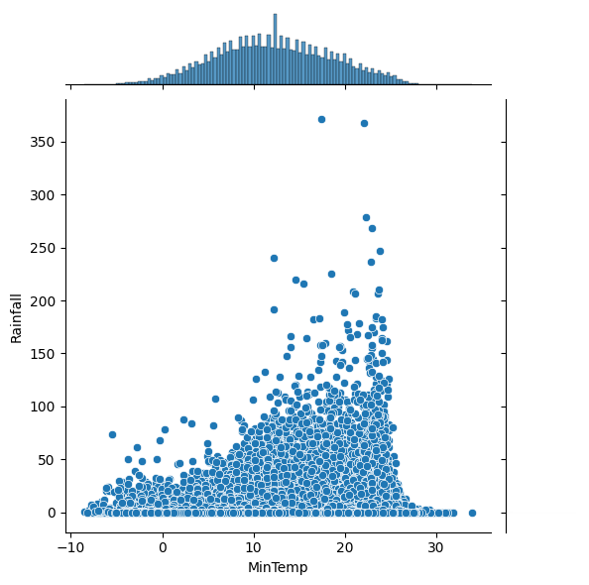

1. **The Jointplot - 2**

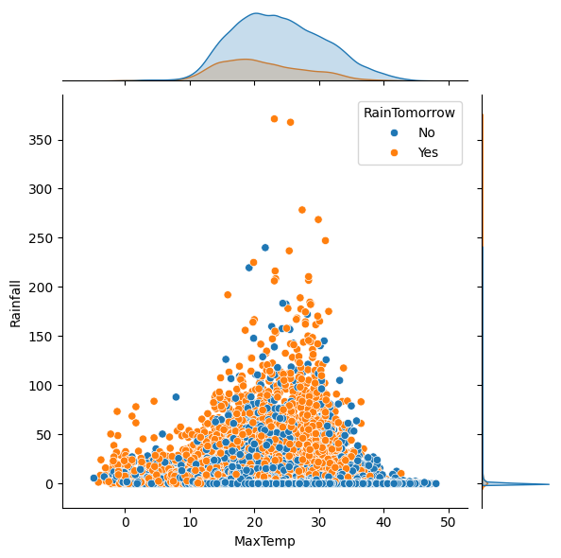

1. **The Histogram**

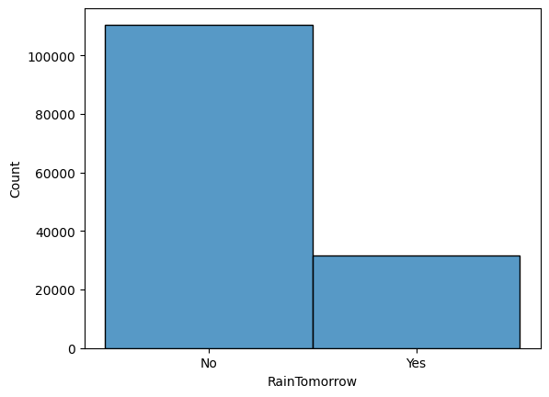

1. **The Scatter Plot**

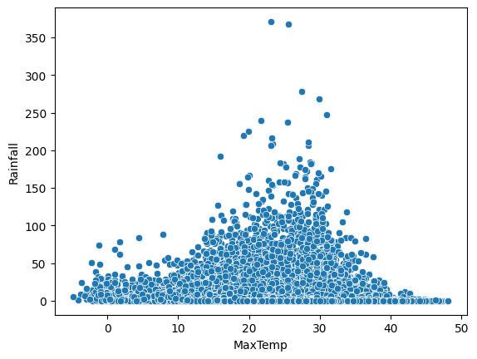

1. **The Distribution Plot**

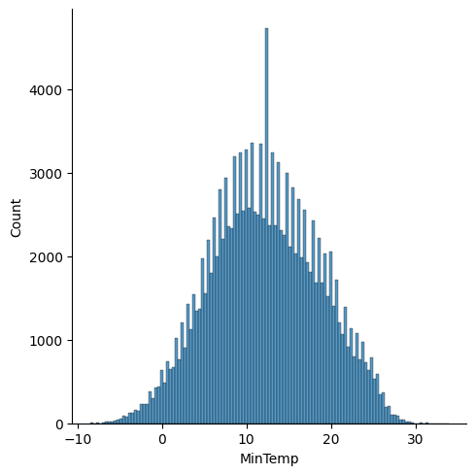

**Splitting the data:**

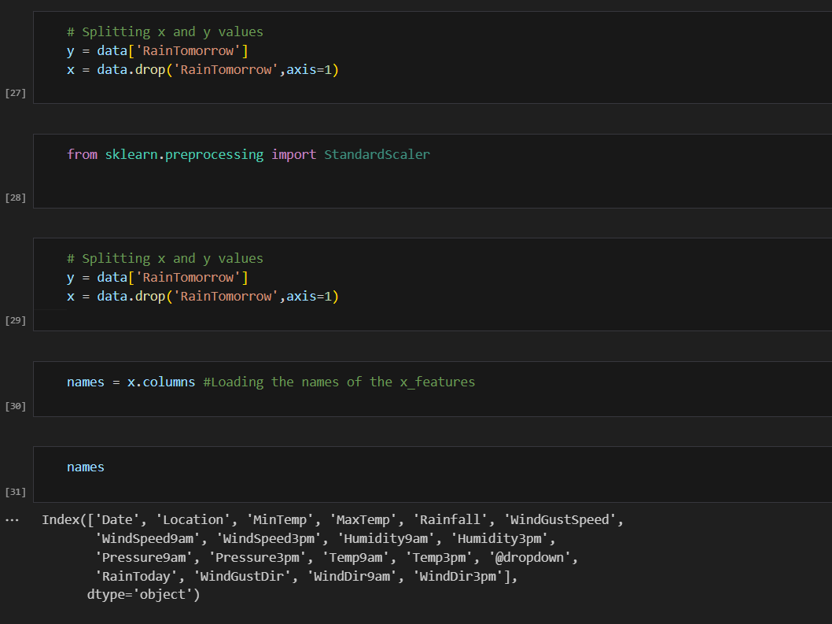

**# Splitting the data into train and test**

**x_train,x_test,y_train,y_test = model_selection.train_test_split(x,y,test_size=0.2, random_state=0)**